Guidelines for Contribution to the Repository   
  
1. Create a folder and name the mechanic   
2. Inside the folder there should be 3 folders as shown in the image

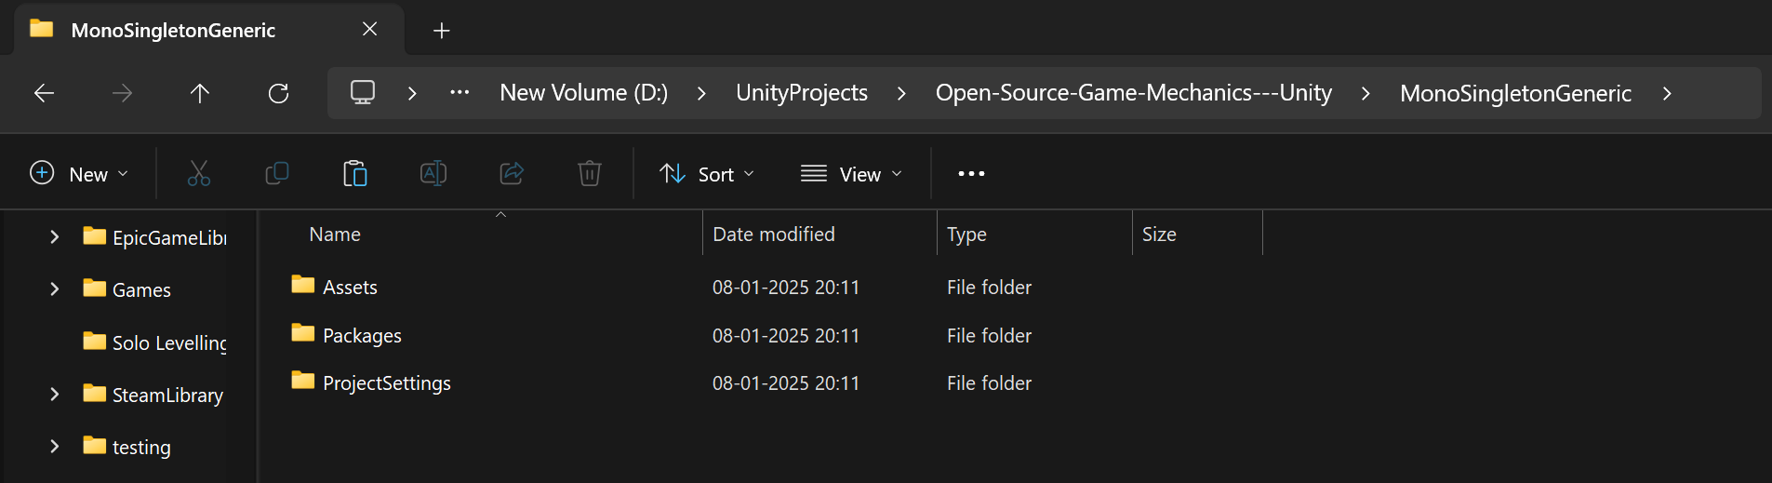

3. Assets folder should contain the following folders as a scene with a demo scene and scripts

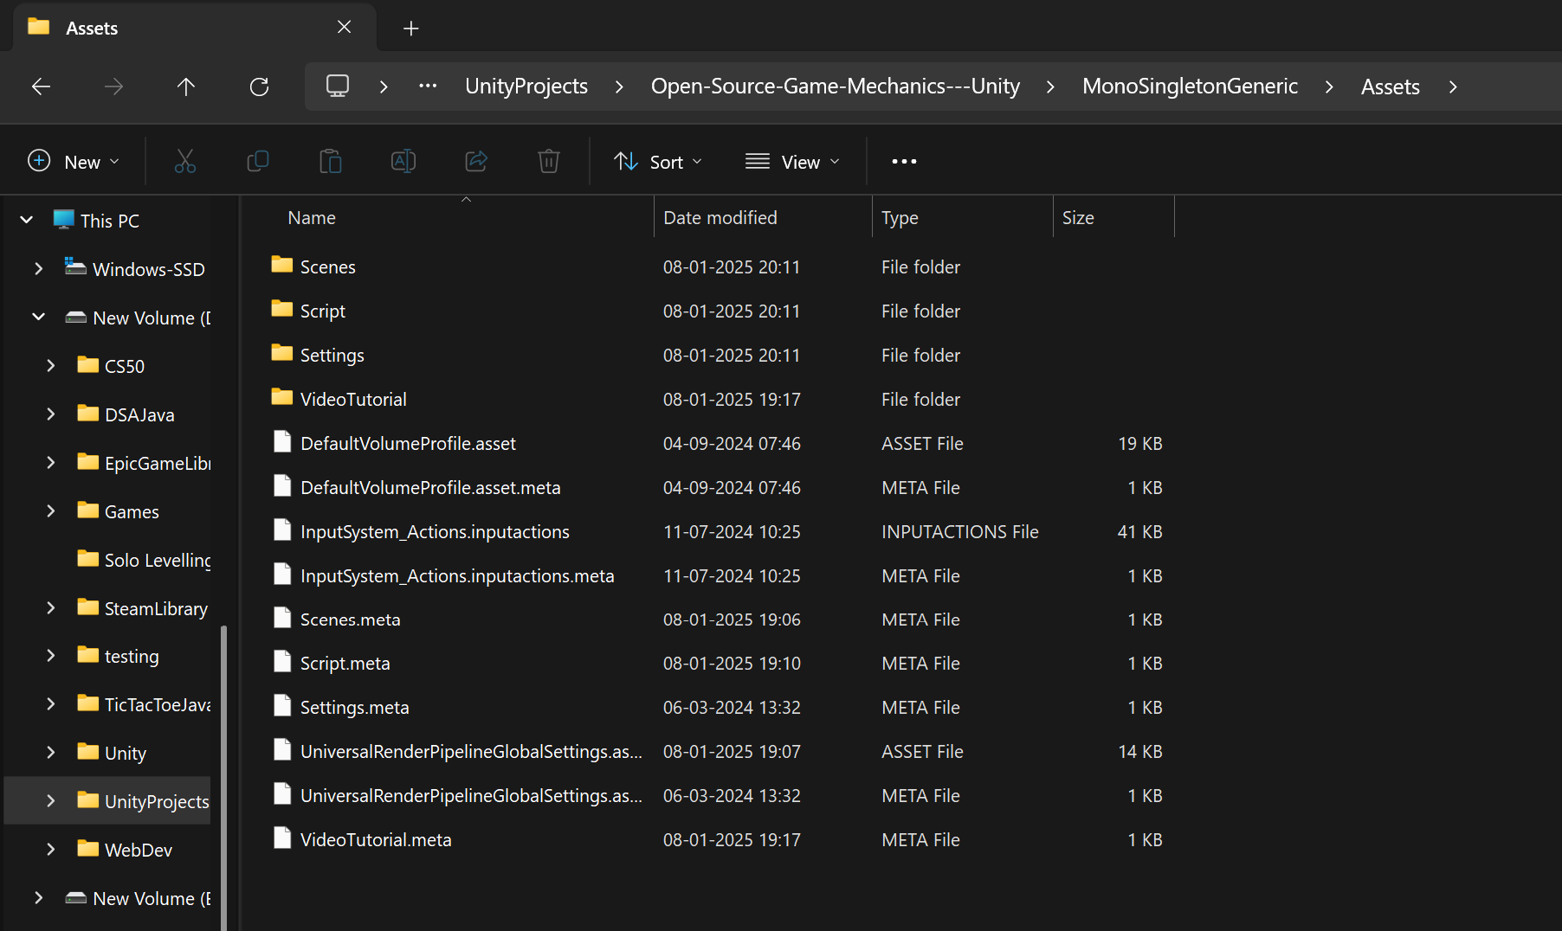

4. The Script folder should have the script

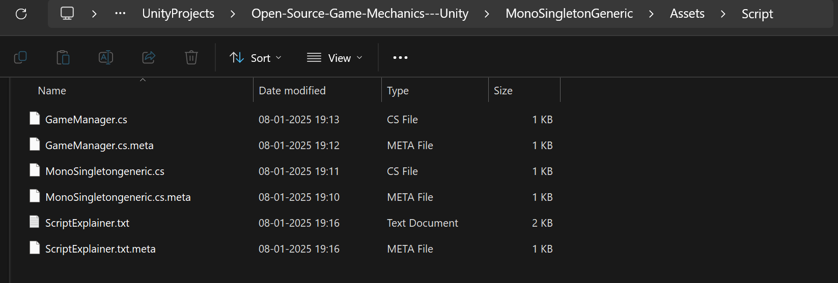

5. A video of how to use the specified script must be made and uploaded as a mp4 file keep the size to be small as possible and possibly 720 p demonstrating the implementation

6. Add a Script Explainer. Txt file which explains the code line by line in format.  
Line1 : code   
Line 2 : comment // Code explanation

Eg.

Code : using UnityEngine;

// Imports the Unity engine's core namespace, giving access to Unity-related classes and functions.

Code :public class MonoSingletongeneric<T> : MonoBehaviour where T : MonoSingletongeneric<T>

// Defines a generic class that inherits from MonoBehaviour. The `where T : MonoSingletongeneric<T>`

// constraint ensures that T must be a subclass of MonoSingletongeneric<T>.

{

Code : private static T instance;

// Declares a private static variable to hold the single instance of the class.

}

7.\* If You contribute to this repo you hereby consent the usage of the code as per the license applied on the repo while also ensuring that the code you have updated in not copyrighted by any other organisation . In case of any copyright infringement occurs due to any code contributed by the contributor the contributor will be held responsible for the same and the owner of the repo holds to right to delete such contributions.